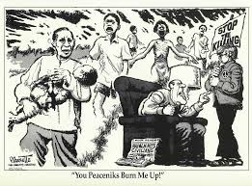

The political cartoon above is portraying the impact of war in Vietnam that made many people to protest against it. Many people feared the consequences of the war. Booming of the South Vietnamese countryside led to mass destruction of Vietnamese homes, wounding and killing loved ones. Many Vietnamese left their rural village and became refugees in the outskirts of towns and cities, hoping that they won’t encounter any more bombings. The American military leaders held discussions on the best ways to conquer Viet Cong guerilla in the countryside and concluded that the only way would be to through bombing the South Vietnamese villages. Many American troops lost their lives in the way. Many Americans feared the negative consequences of the war such as massive deaths and destruction of property. This was one of the arguments against the Vietnam War. Soldiers deserted and a strong resistance was mounted for the US government to withdraw its troops. It was becoming increasingly apparent that the US was losing the war. Many Americans saw the war as a waste of resources and lives and was not significant.

